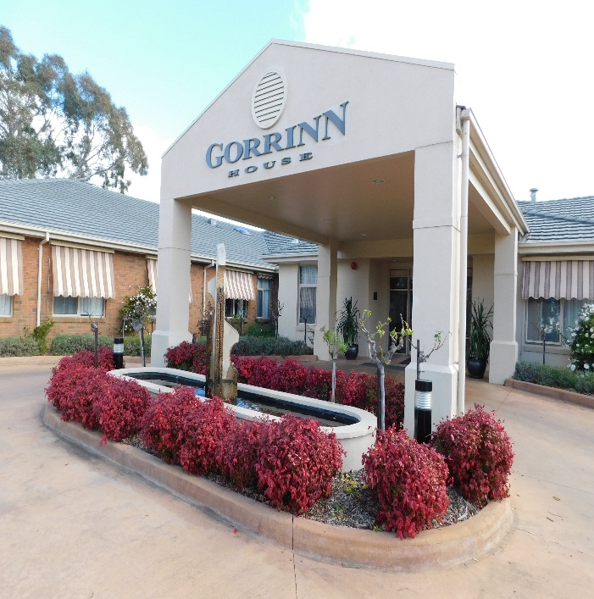

Gorrinn Village
Residential Aged Care & Independent Living

52 ^{nd} ANNUAL REPORT
2021 - 2022

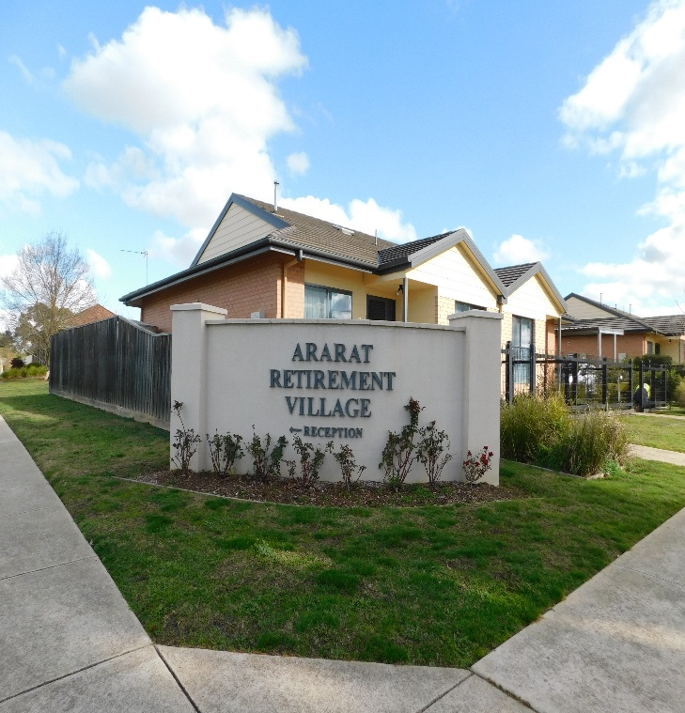
Ararat Retirement Village Inc.

AGENDA FOR THE ANNUAL MEETING OF CONTRIBUTORS AND LIFE GOVERNORS 2021.

The Annual General Meeting of Contributors and Life Governors of Ararat Retirement Village Inc. will be held at Gorrinn Village on Friday 8th October 2021 at 2pm via Zoom

Purpose of the meeting will be:

- To confirm minutes of the Annual General Meeting held on Friday 16th October 2020 and of any General Meeting held since then.

- To receive the report of the Board of Governance and Audited Statement of Accounts for the year ending 30th June 2021.

- To elect the following 7 Board of Governance Members all of whom are eligible for re-election: Dr Derek Pope, Mr Dave Colley, Mr Gary Lewis, Mr Trevor Quick, Mrs Teresa Gemmola and Mrs Anne Shalders

- To transact any other business of which at least seven days’ notice has been given.

- To appoint an Auditor for 2021/2022 financial year.

- Retirement Village Register of Management Concerns and Resident Disputes 2020/21 financial year.

Copies of the Annual Report will be available on the Gorrinn Village website
https://gorrinnvillage.weebly.com

Robyn Woods-Gebler

Chief Executive Officer – Director of Care

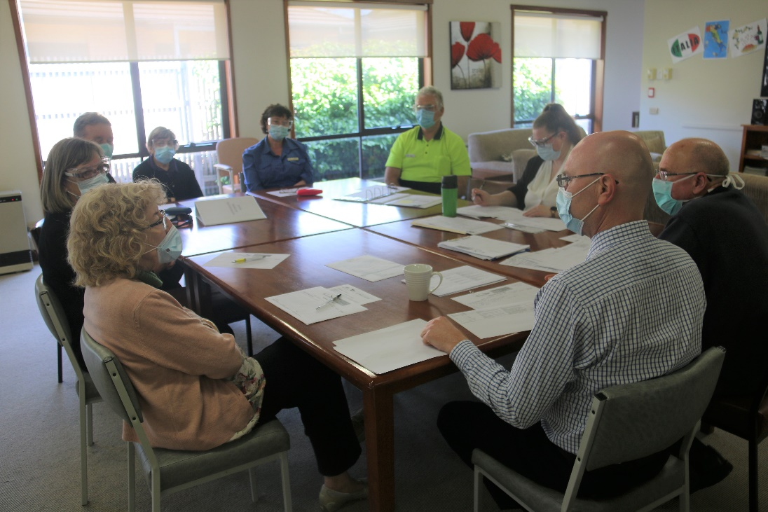
SUKHI & MATTHEW

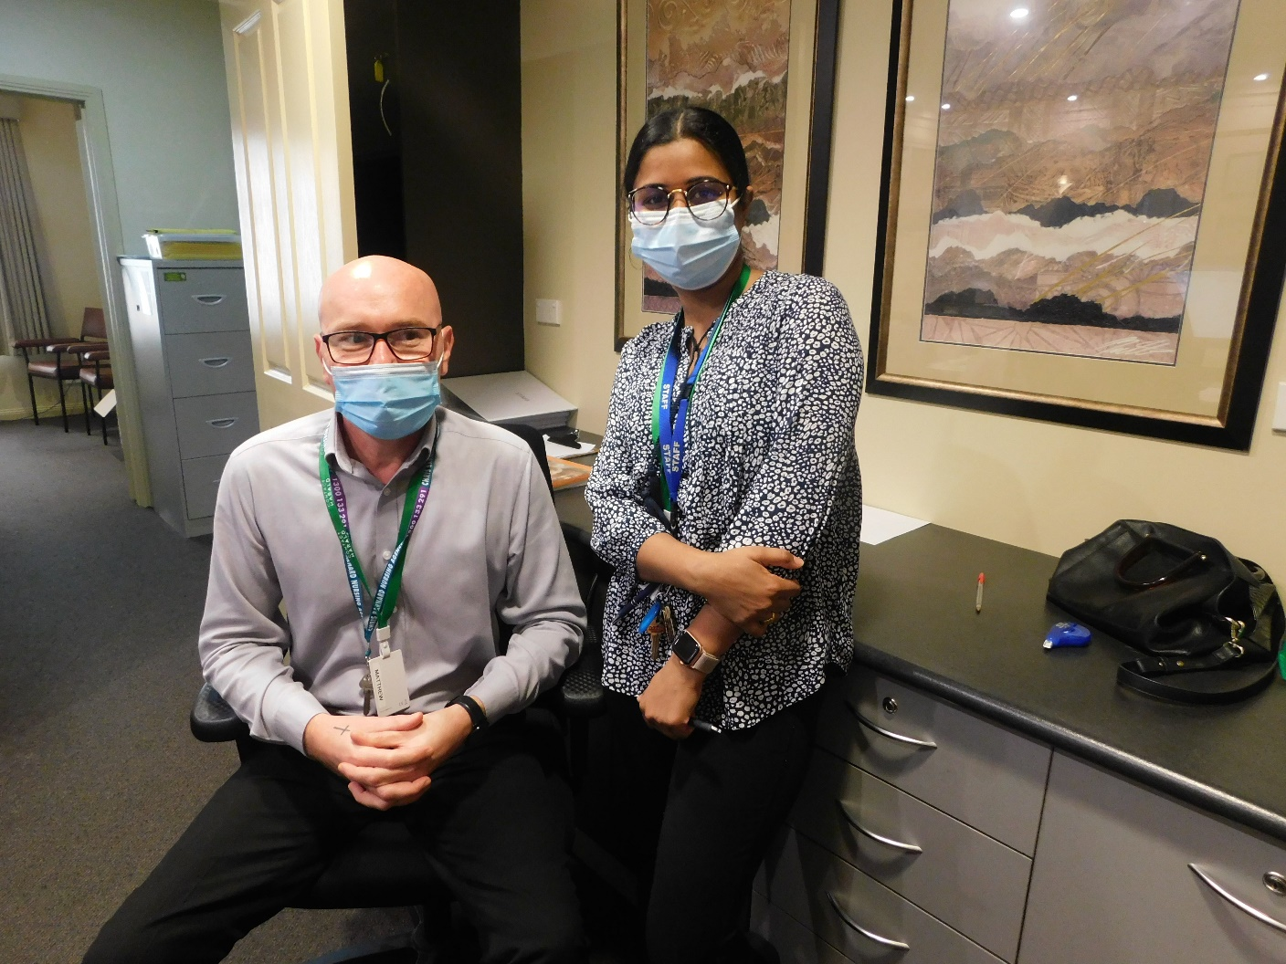

BOARD OF GOVERNANCE
From 1st July 2020 to 30th June 2021

PRESIDENT
Dr D. Pope

SNR VICE PRESIDENT
Mr D. Colley

JNR VICE PRESIDENT
Mrs A. Shalders

HONORARY TREASURER
Mr D. Marland

BOARD OF GOVERNANCE MEMBERS
Dr D. Pope, Mrs T. Gemmola, Mr D. Colley, Mr D. Marland,
Mrs A. Shalders, Ms R. Toomey, Mr P. Roberts, Mr R. Pearse, Mr G. Lewis,
Mr T. Quick

SUB COMMITTEES
President and Chief Executive Officer are ex-officio on all Committees
Finance Committee: D. Marland, P Roberts, A. Dunn, Barb Jardine.
Redevelopment Committee: D. Marland, R. Pearse, T. Gemmola, A. Dunn, P. Roberts, Gary Lewis, Barb Jardine, Neil Murray.

AUDITOR
RSM Australia Partners

ACCOUNTANT
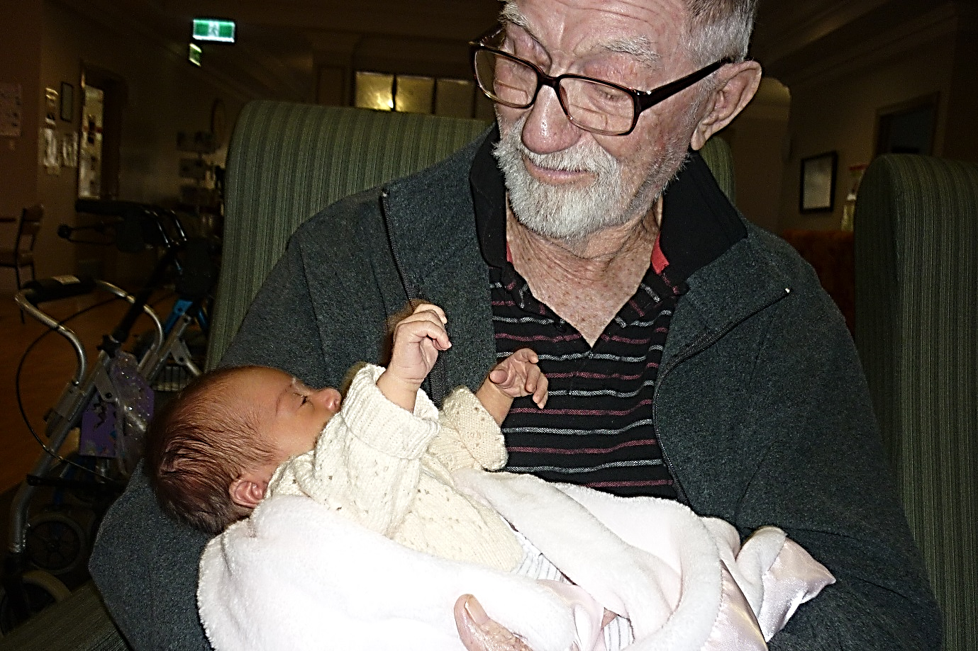
Sertori & Co.

BANKERS
Australian and New Zealand Banking Group

CHIEF EXECUTIVE OFFICER / DIRECTOR OF CARE
Ms Robyn Woods-Gebler

MANAGER – ADMINISTRATION & FINANCE
Barb Jardine

LIFE GOVERNORS

MR F McCARTHY | 1981 | DR D POPE | 2010
MRS S SHANNON | 1984 | MRS S HALVORSEN | 2010
MRS J GUNSTONE | 1991 | MRS J WHEELER | 2010
MR B FRANCIS | 1997 | MR A DUNN | 2016
MRS G RHOOK | 1999
MR P ROBERTS | 2010

DONATIONS
Financial Year to 30/6/21

During the 2020/2021 financial year we received donations from individuals, community organisations, residents and family members.

These donations contribute to care and help to enhance the lifestyle of all our residents at the Retirement Village.

We thank you all

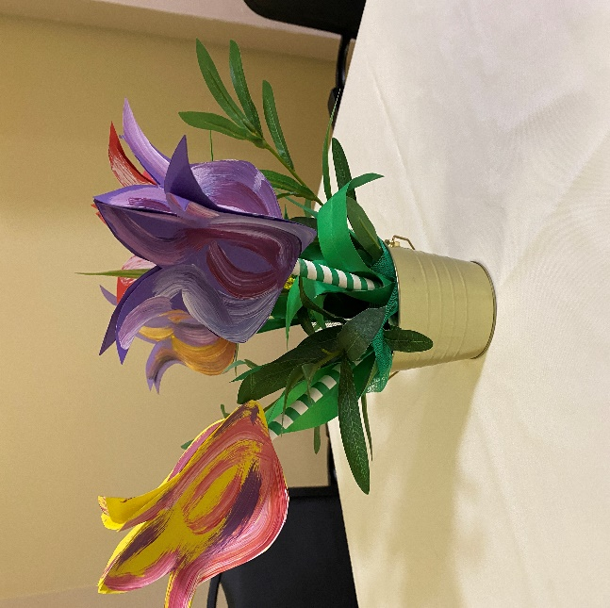

PRESIDENT’S REPORT

2020 – 2021

It is with great pleasure that I present the 51st President’s Report for the Ararat Retirement Village.
This year, 2021, has once again been a year that has stretched our community and our nation in general to the limits. The spread of Covid19 and the race to get our population vaccinated has dominated much of the news and everyday life. As a community, we have grown used to the restrictions, which continue to stress our lifestyles, our work and our relationships with family and friends.
Many of us have spent months unable to see our loved ones due to the lockdown and risk of infection, and this has been very evident in Aged Care facilities around the state. Securing the safety of the residents and managing the risk of Covid19 getting into the Village has been a major undertaking requiring hundreds of hours of work, and a stack of procedure manuals that, Robyn has informed me, is almost a metre high. Every aspect of Village life, its interaction with family visitors and the wider community had to be assessed in great detail in order to eliminate, as far as possible, the risk of the infection getting into the Village. Plans had to be made for the eventuality of one or more of our residents coming down with the virus.
The Village, its residents, staff and management can be very proud of the fact that Gorrinn Village is one of relatively few aged care organisations that have achieved 100% vaccination of all residents and staff. This shows the extraordinary commitment from everybody to ensure that we are protected as well as possible from the ravages of a potential Covid19 outbreak locally.
The sheer volume of planning was staggering, and, on behalf of the Board, I would like to express our deep admiration and appreciation to Robyn, Barb and indeed all the staff for their tireless efforts and work in keeping Gorrinn Village safe and running as close as possible to normal in the extraordinary times.
Otherwise, Gorrinn Village has once again had a successful and interesting year, with a modest increase in our operating surplus despite the challenges. In line with our long-term plan to continually maintain and upgrade the Independent Living Units, there, as always, has been further and ongoing work on the Bishop Court and Princes St units as part of our continuing cycle of refurbishment and upgrades. All the units are currently occupied, with enough interest in the units still to maintain hopefully full occupancy for some time. But there has always been the need to plan for the future and ensure that the Village complex can grow to accommodate our older citizens at all levels of care, and, as before, much of the discussion at Board level over the past year has concerned the 15-bed extension along with the redevelopment of the kitchen and administration facilities.
After many months of planning, the contract for the building works was put up for tender and Bowden Corp, a large company based in Melbourne and Geelong, with much experience in local Aged Care construction, was selected. Despite delays due to covid19 restrictions, preliminary work has commenced and the end of the current old car park (soon to disappear forever!) and should be nearing completion by the middle of next year.

I would like to acknowledge the long hours and hard work of our CEO Robyn Woods-Gebler. As always, Robyn has kept the Village running smoothly with close attention to resident care and staffing. As before, her work has been augmented by the addition of regular registered nurses in the roster, creating an enhanced level of service to the residents. Also as always, Robyn has been assisted by Barb Jardine, our invaluable financial manager. Aided by our dedicated staff, they have maintained the high standards of care and have made the Village a caring, homelike environment that, I hope, fulfils the expectations of our residents.
I would like to thank the members of the Ladies Auxiliary for their dedicated and ongoing support of the Village residents. Thanks also to the volunteers who give up many hours of their time for the enjoyment of the residents.
Finally, I would like to thank my fellow Board Members. Without the presence, enthusiasm, and long hours of work and study by the Board, I am sure that the Village would not be the way it is today. In particular, I would like to thank the Building Committee who worked hard to make out impending new development as success. Despite our trials and tribulations, I am sure that the Board will be able to meet the challenges of the next few years with confidence and energy and keep Gorrinn Village moving forward.

Dr Derek Pope
President – Board of Governance

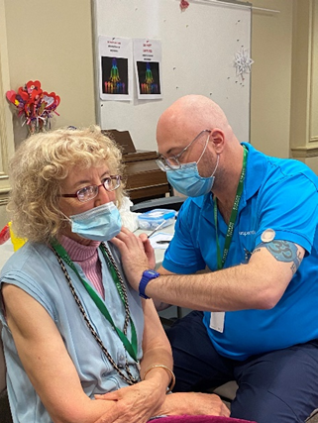

REPORT OF CHIEF EXECUTIVE OFFICER/ DIRECTOR OF CARE

I had hoped that by the time I wrote this I would be able to say that the pandemic was behind us, but that is not the case. At the beginning of the financial year, we were in the grip of the first wave in Victoria and at the end we were about to enter another large outbreak. There were at least some relatively normal months over Christmas which was great.

While Covid remains and the Delta variant changed everything we knew about it, vaccines arrived and have and will make a huge difference. Village residents and staff were vaccinated as soon as we could and having that 100% cover has been very reassuring. Unfortunately, Covid did affect our redevelopment – pushing the start back into the 2021-2022 financial year and consequently the completion into early 2023.

Also, we are limited to an online AGM again and the postponement of our 50th anniversary celebrations. At this stage we are hoping for 50 plus 2 next year.

However, there has been more than just Covid happening in aged care this year. A number of the recommendations from the Royal Commission have arrived with a huge increase in regulatory reporting. These, and a similar increase in finance reporting have almost become full time tasks for Barb Jardine and myself. Unfortunately, it is no longer enough to provide good care, it is now necessary to endlessly document and collect evidence to prove you have done so.
The proposed new funding instrument for residential care did not commence as expected and the Commonwealth have already stated that there is no guarantee that it will not result in less funding per resident which is a concern.

This is at odds with the results of the Royal Commission and the demands from the unions both of whom want more staff, better pay and a host of other recommendations that facilities would struggle to afford with current funding let alone with a decrease.

Amongst all the gloom has been the wonderful support of our residents and staff. While initially understandably quite anxious about the pandemic, they have all pulled together and coped very well. They embraced vaccination with enthusiasm, correctly seeing it as the best way forward and due to the efforts of the staff and our determination not to alter the routines within the facility, the residents also coped well with the various restrictions on visiting which altered so frequently.

As it has been a team effort, we are not singling anyone out for the President’s award this year. Instead, we are congratulating all our staff for making sure everyone got through it with a minimum of fuss. When we can we will have a really good party to celebrate their dedication.
I would also like to thank the Board who, while always very supportive, have been even more so this year, and of course Barb, who’s efforts, as always, have gone above and beyond.

Robyn Woods-Gebler
Chief Executive Officer/Director of Care

GORRINN HOUSE LADIES AUXILIARY REPORT
2020-2021

I am pleased to present the Ladies Auxiliary report for 2021.

This past 12 months has been quiet for the Auxiliary because of the ongoing issues with COVID lockdowns.

We were late starting back after our winter break. As a result, we did not have our AGM until November (Usually held in September). In 2021 we managed to have monthly meetings until May (minus February) when we recessed for winter. To date we have not been able to recommence meetings again

As well because of COVID restrictions we have been unable to have our regular interaction with residents post our meetings for afternoon tea.

We were unable to host our Christmas party for residents in 2020. Hopefully we can host another party this December, fingers crossed.

We did make lots of shortbread & put these into bundles for the residents in lieu of not being able to hand them out personally.

Also, during the year residents were given Easter treats, flower posies on Mother’s Day & chocolates on Father’s Day

We have gone back to opening the kiosk for the residents twice a week when we have been able.
Also, we were able to fit in a Education Program for Volunteers that included fire safety protocols & practices in the village.

We purchased two sets of indoor games for the residents to play including indoor croquet.
The anticipated second Open Garden Day has been delayed for another year. It was felt even if restrictions are lifted by the end of October the logistics of running it this year were going to be very difficult. We have five wonderful gardens lined up so hopefully we will be able to conduct it in 2022. Thanks to the Pam & Peter Brennan, Mary & Geoff White, Shelley Greene, Margie Kilpatrick & Les & Barbara Gason for agreeing to participate & committing to 2021.

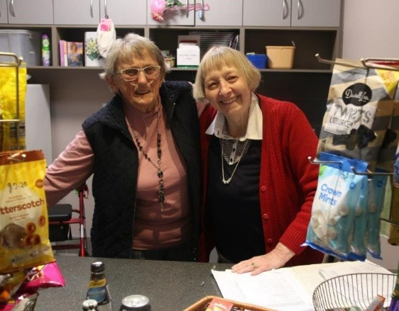
The village residents have again been very fortunate to have such a dedicated and wonderful group of staff who have kept them safe through the COVID lockdowns. So, thank you again to Robyn Woods-Gebler and Barbara Jardine and all the staff.

I know many of our members miss catching up with the residents each month, and hopefully will be able to do so sometime soon, all being well.

So, it is with much pleasure I present the annual report on behalf of the Gorrinn Ladies Auxiliary.

Helen Boling
President – Ladies Auxiliary

